Woodford Primary School


YEAR 6

END OF YEAR EXPECTATIONS

A GUIDE FOR PARENTS & CARERS
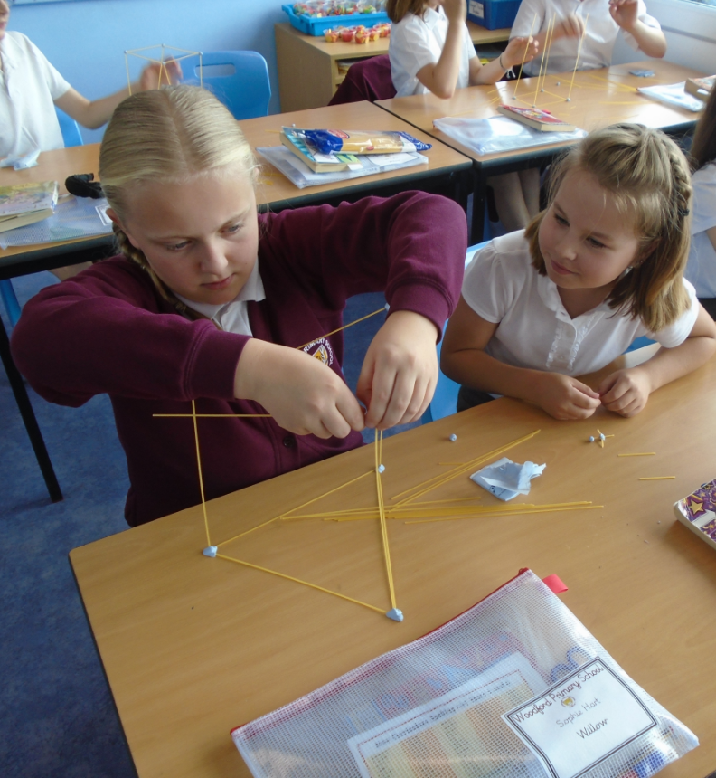

This booklet provides information for parents and carers on the end of year expectations for children in our school.

These expectations are the minimum requirements your child must meet in order to ensure continued and expected progress throughout the following year.

All the objectives will be worked on throughout the year and will be the focus of direct teaching.

Working Towards the age related expectations:
This means a child needs to continue to practise these skills.

Working At the age related expectations:
This means a child can use these skills on their own.

Working at Depth at the age related expectations:
This means a child can independently use these skills and apply them to a range of learning experiences.

Any extra support you can provide in helping your children to achieve these is greatly valued and will help your child reach their full potential.
Reading



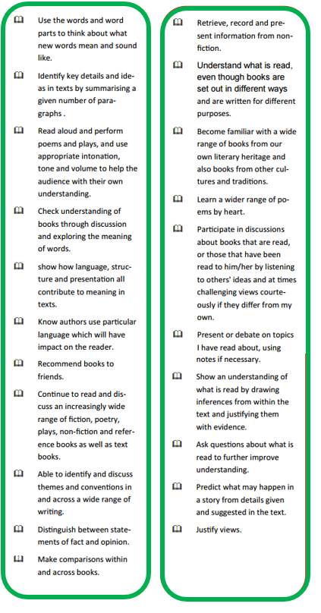
Encourage your child to read every day and support their understanding through asking questions. Encourage your child to read a range of genres through the Scholastic scheme.
KEY BOOKTALK QUESTIONS
Was did you about this book/text?
What did you dislike about this book/text?
What puzzles you?
What interested you the most?
Make use of our online resources to support your child’s learning.
WHAT I CAN DO TO HELP MY CHILD:

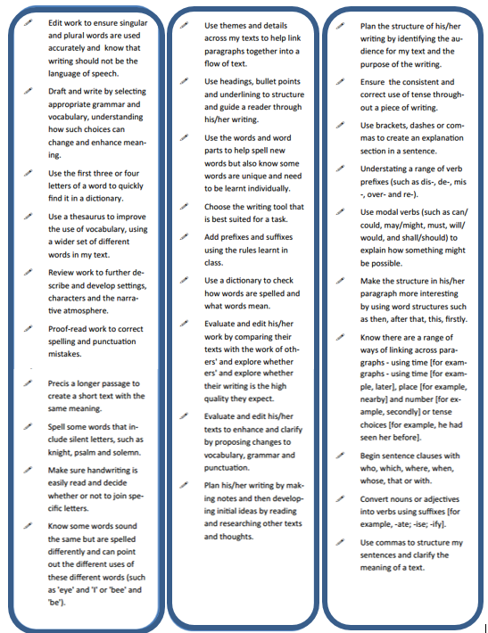

Writing

Encourage their personal writing, for example, a journal or diary, social networking, a blog. But ensure you take necessary safeguards when using the internet.

Gifts of Writing. Greeting cards with personal messages and poems are more meaningful when they're homemade, rather than store-bought.
Supporting your child for writing can help them voice ideas and express themselves. Talk to them about the types of writing they are doing in school.
WHAT I CAN DO TO HELP MY CHILD:



Make use of our online resources to support your child’s learning.
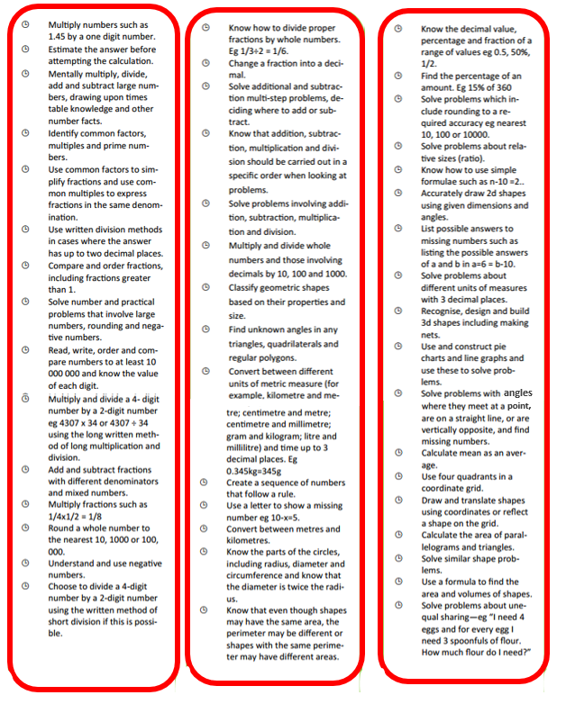

Maths

Make use of our online resources to support your child’s learning.
Help your child to recite their times tables and recall them at speed. Use the Times Tables Rock Stars. programme at home.
Talk about maths whilst cooking, looking at travel timetables and planning journeys, looking at TV schedules, adding up shopping bills.
WHAT I CAN DO TO HELP MY CHILD:




SUPPORT AT HOME

There are many ways parents and carers can help children at home. It would be helpful if you could :-

- Ensure your child has a calm quiet working space.
- Talk with your child about what they are learning and the homework they have been set.


Ideally, parents should read with or listen to their children daily to help them to develop fluency, confidence and a love for reading.


If parents and carers have any questions about homework or their child's learning they should, in the first instance, contact their child’s class teacher via Class Dojo.


www.woodfordprimary.co.uk

