Woodford Primary School


YEAR 1

END OF YEAR EXPECTATIONS

A GUIDE FOR PARENTS & CARERS
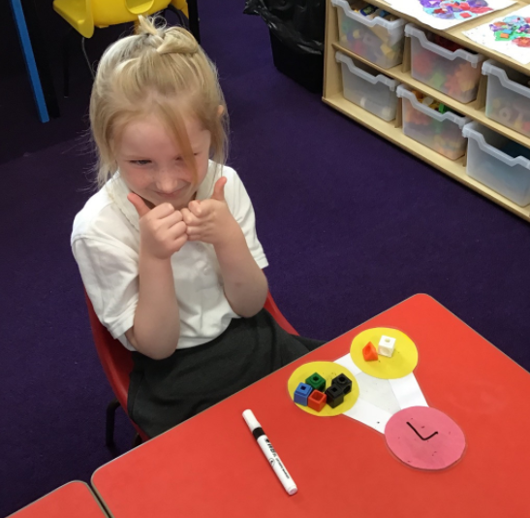

This booklet provides information for parents and carers on the end of year expectations for children in our school.

These expectations are the minimum requirements your child must meet in order to ensure continued and expected progress throughout the following year.

All the objectives will be worked on throughout the year and will be the focus of direct teaching.

Working Towards the age related expectations:
This means a child needs to continue to practise these skills.

Working At the age related expectations:
This means a child can use these skills on their own.

Working at Depth at the age related expectations:
This means a child can independently use these skills and apply them to a range of learning experiences.

Any extra support you can provide in helping your children to achieve these is greatly valued and will help your child reach their full potential.
Reading
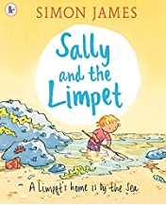







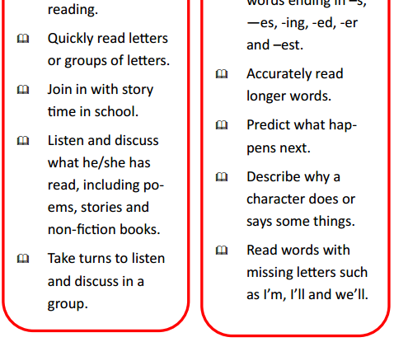
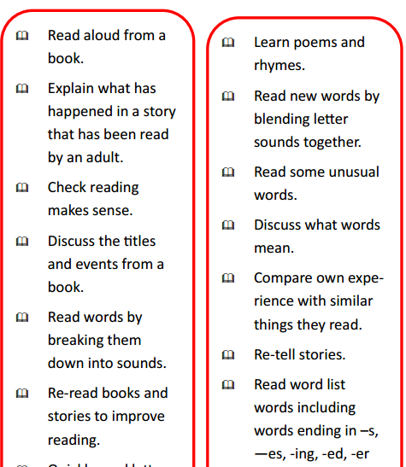
Make use of our online resources to support your child’s learning.
Allow your child to read at their own pace and encourage them to re-read their favourite stories. This will help to begin recognising familiar letters, words and develop fluency.
Read books with your child and talk about the story, the poems or the information in them. What parts of the book have they enjoyed the most and why?
WHAT I CAN DO TO HELP MY CHILD:


Writing

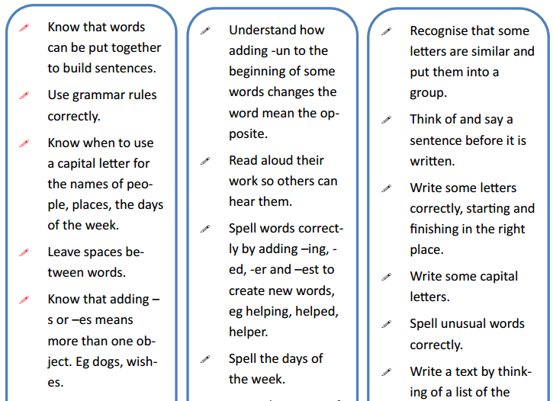
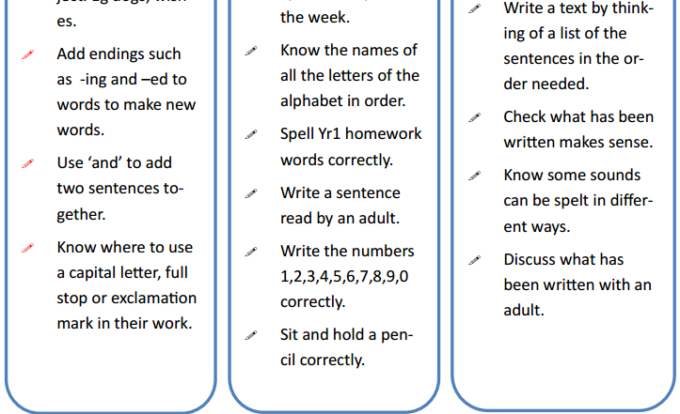
WHAT I CAN DO TO HELP MY CHILD:

Make use of our online resources to support your child’s learning.


Encourage your child to want to write. Let them use crayons, pencils, felt-tips & paints to make patterns and pictures.

Find lots of opportunities to write together—make lists before you go shopping, and write letters to friends and family. Help them to make their own books, posters or labels for things in their room.

Maths

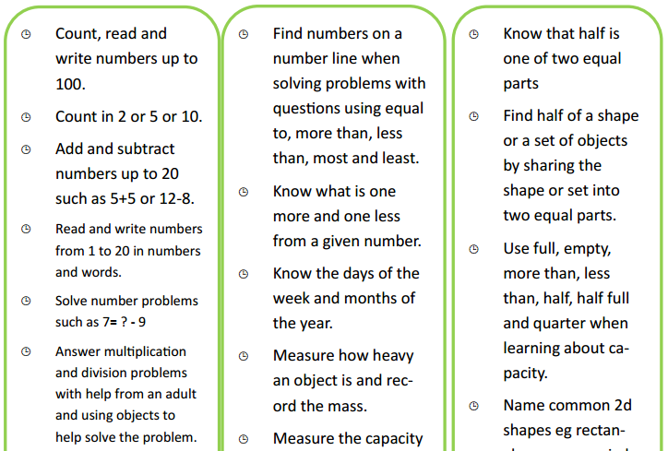
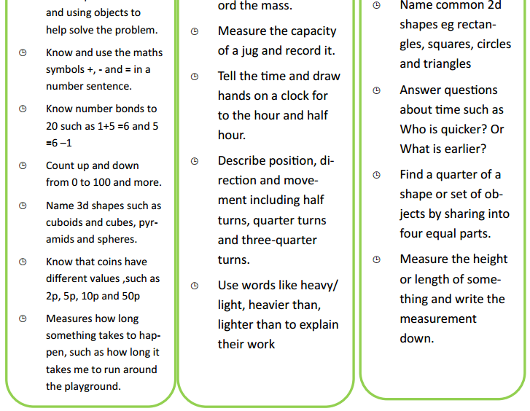
Help your child to count forwards and backwards from a given number. Help them to recall number facts such as doubles and bonds to 10 at speed.
Make use of our online resources to support your child’s learning.
WHAT I CAN DO TO HELP MY CHILD:




SUPPORT AT HOME

There are many ways parents and carers can help children at home. It would be helpful if you could :-

- Ensure your child has a calm quiet working space.
- Talk with your child about what they are learning and the homework they have been set.


Ideally, parents should read with or listen to their children daily to help them to develop fluency, confidence and a love for reading.


If parents and carers have any questions about homework or their child's learning they should, in the first instance, contact their child’s class teacher via Class Dojo.


www.woodfordprimary.co.uk

